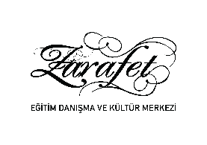

Dear Professor Mrs. Dr. Melda Yıldız ;
Education Advisory elegance and Cultural Center, Aziz Mahmud Hudayi in Turkey Foundation is a unit of ladies training services.
Aziz Mahmud Hudayi Foundation is named after Aziz Mahmud Hudayi, who served as a judge during the Ottoman period, then peaked in Islamic sciences and provided spiritual guidance to people. This foundation is an institution that voluntarily assists people in need and also provides educational services.
Zarafet Education Counseling and Culture Center is an institution that prepares programs for children, young and adult women to develop and support their development within the framework of Islamic culture and civilization values.
Since the first week, we have been participating in the 4-week 'In-Service Training Program', sponsored by Acıbadem College, under the leadership of the Education of Tomorrow, with 26 trainers working in our institution. In your education, you have created great awareness in us. You have opened our horizons to teach students how to use knowledge to make it permanent in their minds and to use it functionally.
Thank you for the valuable information you provided. We wish you success in your work.

Elegance Education Consultancy and Cultural Center Management

